**A-Level Computer Science - Abstract Data Types (Stacks + Queues)**

**Programming Task**

You are going to build a program that models both a Stack and a Queue to allocate Ice Cream vans to employees.

Task 1:

Design a form that looks like the following:

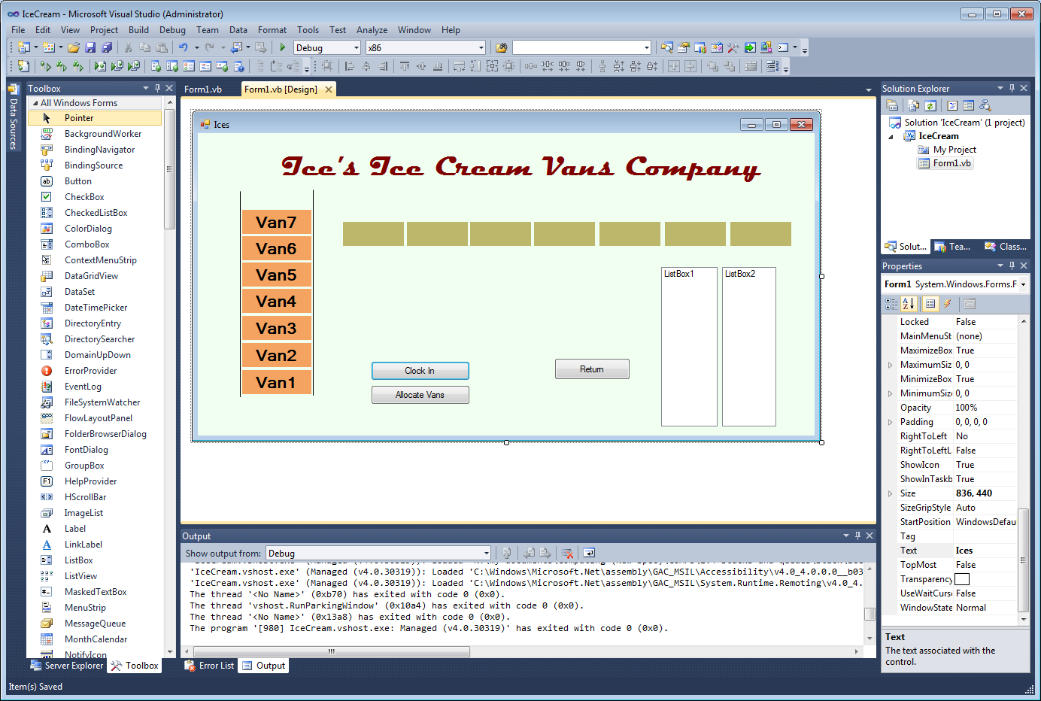

1. There is going to be a Stack of ice cream vans – shown above with each label already containing the ice cream van in the yard. Van1 up to Van7. These are in labels 1-7
2. There is going to be a Queue of Employees shown (as a queue) with empty labels – this array of lables is label7 to label13

Task 2:

Set your variables and Form_Load up as follows:

Dim Vans(6) As Label

Dim people(6) As Label

Dim maxQ As Integer = 7

Dim noInQ As Integer = 0

Dim front As Integer = 1

Dim rear As Integer = 6

Dim Queue(7) As String

Dim tpStack As Integer = 7

Private Sub Form1_Load(sender As System.Object, e As System.EventArgs) Handles

Vans(0) = Label1

Vans(1) = Label2

etc

people(0) = Label8

people(1) = Label9

etc.

**Task 3:**

Code the clock in buttons:

1. Allow the entry of a new person via an inputbox into a variable “newPerson”
2. Write a procedure for adding to a Queue
3. Call the adding to the Queue procedure from the clock in button

Test the program and check that when people are added using clock-in button that they display in the Queue

**Task4:**

Code the allocate vans button:

1. Set up a For Loop as follows:

For index = 1 To noInQ

ListBox1.Items.Add(RemoveFromQueue)

ListBox2.Items.Add(POP)

Next

1. Create a RemoveFromQueue Function

This returns the first item in the queue

1. Create a Pop Function

This pops an Item off the stack and returns the item

**Task5:**

Code the Return button

1. Add the following code into the return button:

Dim position As Integer

position = ListBox1.SelectedIndex

Push(position)

1. Create a Push Procedure

This pushes the Van back onto the Stack (we don’t need to worry about the person)

You will need these few lines of code to help:

Vans(tpStack - 1).Text = ListBox2.Items.Item(pos)

ListBox2.Items.RemoveAt(pos)

ListBox1.Items.RemoveAt(pos)